RESOLUTION NO.__________

RE: CERTIFICATE OF APPROPRIATENESS UNDER THE
PROVISIONS OF THE ACT OF THE PENNSYLVANIA
LEGISLATURE 1961, JUNE 13, P.L. 282 (53
SECTION 8004) AND BETHLEHEM ORDINANCE NO.
3952 AS AMENDED.

WHEREAS, it is proposed to secure a COA to repair the façade per results of Engineer’s recommendations at 314 Broadhead Avenue.

NOW, THEREFORE, BE IT RESOLVED by the Council of the City of Bethlehem that a Certificate of Appropriateness is hereby granted for the proposal.

Sponsored by: (s)

(s)

ADOPTED BY COUNCIL THIS DAY OF

(s)
President of Council

ATTEST:

(s)
City Clerk

HISTORIC CONSERVATION COMMISSION

CASE #661 -- It is proposed to repair the façade per results of Engineer’s recommendations at 314 Broadhead Avenue.

OWNER/APPLICANT: Eugene Mish and Michael Mish/Eugene Mish and Michael Mish

The Commission upon motion by Mr. Loush and seconded by Mr. Cornish adopted the proposal that City Council issue a Certificate of Appropriateness for the proposed work as presented and described herein:

- The proposal to repair the façade per results of Engineer’s recommendations was presented by Eugene (Gene) Mish.
- Approved repairs include:
  - remove existing (failing) brickote stucco veneer as well as outer-most wythe of original brick, stabilize substrate and re-face with real brick units to match original by recreating original details (vertical pilasters, corbeling at upper cornice, etc.); note: thin-brick veneer is unacceptable
  - devise weather-tight solution at current lower cornice, with subsequent building owner responsible for installing new cornice to match details of adjacent building at 316 Broadhead Avenue
- The motion for the proposed work was unanimously approved.

JBL: jbl
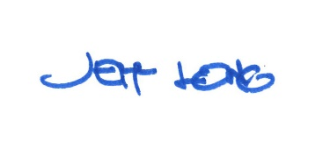

By:

Date of Meeting: August 20, 2018 Title: Historic Officer

